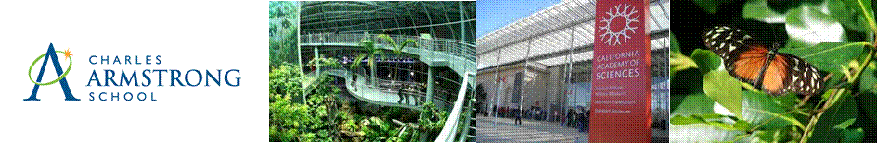

2016 CHARLES ARMSTRONG SCHOOL COMMUNITY FUNDRAISER RAFFLE
We are asking each family to sell at least 12 books

THE TICKET PRICES ARE:
5 AMAZING RAFFLE PRIZES
Hawaii Family Trip for 4
Disneyland & Knott’s Berry Farm trip for 4
$1000 Gift Card
GoPro Hero4 Black (or $500 Gift Card)
Beats Solo² Wireless Headphones
(or $250 Gift Card)

- $10 per ticket
- $30 per book of 5 tickets

PRIZES FOR TICKET SELLERS (STUDENTS)
- The top 12 selling students will go to Benihana for lunch in a Limo on May 11, 2016.
- The top selling middle school classroom will receive a Movie and Pizza Party.
- The top selling lower school classroom will receive an Ice Cream Party.
- Weekly Random Drawing - We will have prize drawings each Monday per class. To be eligible, students have to turn in at least one sold ticket stub the previous week.

SELLING DETAILS
- Sell to family and friends.
- Students will sell from February 23 through April 8.
- Checks should be made out to “Charles Armstrong School.”
- Make sure your name and room number is on the ticket stub as the “seller.”
- Make sure the person to whom you sell puts his/her contact information on EACH ticket stub.
- You must turn in all checks/money and ticket stubs to your homeroom teacher NO LATER THAN 9AM on Monday April 11, 2016.
- Additional tickets available in Room 1 or contact Jill Jacobson jjacobson@charlesarmstrong.org
- Raffle winners will be chosen at an all-school assembly on Tuesday April 12, 2016.
- Prizes are described in detail on a flyer in the envelope.

QUESTIONS?
- Contact Jill Jacobson at jjacobson@charlesarmstrong.org or 650-592-7570 ext. 1265

